WEATHER TRACKER
A Minor Project Report
Submitted in partial fulfillment of requirement of the
Degree of
BACHELOR OF SCIENCE
IN
COMPUTER SCIENCE
BY
MAYANK PUNDLIK
SC23CS302023
Under the Guidance of
Dr. Rohit Gupta
Prof. Shrikant Telang

Department of Computer Science & Engineering
Faculty of Engineering
MEDICAPS UNIVERSITY, INDORE- 453331
APRIL-2026

Report Approval
The project work "WEATHER TRACKER" is hereby approved as a creditable study of a computer science subject carried out and presented in a manner satisfactory to warrant its acceptance as prerequisite for the degree for which it has been submitted.
It is to be understood that by this approval the undersigned do not endorse or approve any statement made, opinion expressed, or conclusion drawn therein, but approve the "Project Report" only for the purpose for which it has been submitted.

Internal Examiner | External Examiner
Name: | Name:
Designation: | Designation:
Affiliation: | Affiliation:

Declaration
I hereby declare that the project entitled "WEATHER TRACKER" submitted in partial fulfillment for the award of the degree of BACHELOR OF SCIENCE in COMPUTER SCIENCE completed under the supervision of Dr. Rohit Gupta, Prof. Shrikant Telang, Faculty of Engineering, Medi-Caps University Indore is an authentic work.
Further, I declare that the content of this project work, in full or in parts, has neither been taken from any other source nor has been submitted to any other institute or university for the award of any degree or diploma.

Signature and name of the student with date
MAYANK PUNDLIK

Certificate
I/We, Dr. Rohit Gupta, Prof. Shrikant Telang, certify that the project entitled "WEATHER TRACKER" submitted in partial fulfillment for the award of the degree of BACHELOR OF SCIENCE in COMPUTER SCIENCE by MAYANK PUNDLIK is the record carried out by him under my/our guidance and that the work has not formed the basis of award of any other degree elsewhere.

Internal Guide | Co-Guide
Dr. Rohit Gupta | Prof. Shrikant Telang
Department of Computer Science & Engineering | Department of Computer Science & Engineering
Medi-Caps University, Indore | Medi-Caps University, Indore

Dr. Kailash Chandra Bandhu
Head of the Department
Department of Computer Science & Engineering
Medi-Caps University, Indore

Acknowledgements
I would like to express my sincere gratitude to the university authorities and faculty members for providing the facilities, guidance, and encouragement required to complete this minor project.
I am deeply thankful to Dr. Rohit Gupta and Prof. Shrikant Telang for their valuable guidance, suggestions, and support during the development of the Weather Tracker project. Their feedback helped me improve both the technical implementation and the project documentation.
I also thank the Department of Computer Science for giving me the opportunity to work on a practical web development project involving API integration, responsive design, testing, and documentation.
Finally, I thank my family and friends for their constant motivation and support throughout the completion of this project report.

MAYANK PUNDLIK
Department of Computer Science
Faculty of Science
Medi-Caps University, Indore

Abstract
Weather information is an important part of daily decision-making because it supports travel planning, outdoor activity planning, agriculture, business operations, and general safety. Many commercial weather platforms provide large amounts of information, but they may also include advertisements, unnecessary screens, and complex navigation. The Weather Tracker project is designed as a lightweight and user-friendly web application that provides essential real-time weather information through a simple interface.
The system allows a user to enter the name of any city and receive current weather information such as temperature in Celsius, humidity percentage, wind speed, wind direction, and weather condition. The application uses HTML for structure, CSS for layout and visual design, and JavaScript for input validation, API communication, JSON processing, error handling, and dynamic display updates. It communicates with the Open-Meteo geocoding and forecast APIs over HTTPS, so the system can fetch live data without requiring a secret API key in the client-side code.
The project follows a function-oriented and layered design. The presentation layer contains the responsive user interface, the application layer performs validation and data processing, and the data layer is represented by the external weather API. The application handles invalid city names, empty input, network failure, and delayed API responses through meaningful user-friendly messages. Recent searches are stored locally in the browser to improve usability during repeated searches.
The final result is a working weather tracking website that is simple, responsive, fast, and suitable for academic demonstration. It also provides a foundation for future enhancements such as forecast display, location-based weather detection, alerts, user personalization, and mobile application support.
Keywords: Weather Tracker, API Integration, JavaScript, JSON, Responsive Web Design, Open-Meteo, Real-Time Weather

Table of Contents
 |  | Page No.
 | Report Approval | ii
 | Declaration | iii
 | Certificate | iv
 | Acknowledgement | v
 | Abstract | vi
 | Table of Contents | vii
 | List of Figures | viii
 | List of Tables | ix
 | Abbreviations | x
 | Notations & Symbols | xi
Chapter 1 | Introduction | 1
 | 1.1 Introduction | 1
 | 1.2 Literature Review | 2
 | 1.3 Objectives | 3
 | 1.4 Significance | 4
 | 1.5 Research Design | 4
 | 1.6 Source of Data | 5
 | 1.7 Chapter Scheme | 5
Chapter 2 | REQUIREMENTS SPECIFICATION | 6
 | 2.1 User Characteristics | 6
 | 2.2 Functional Requirements | 7
 | 2.3 Dependencies | 8
 | 2.4 Performance Requirements | 8
 | 2.5 Hardware Requirements | 9
 | 2.6 Constraints & Assumptions | 9
Chapter 3 | DESIGN | 10
 | 3.1 Algorithm | 10
 | 3.2 Function Oriented Design | 11
 | 3.3 System Design | 12
 | 3.4 Database Design | 16
Chapter 4 | Implementation, Testing, and Maintenance | 17
 | 4.1 Languages, IDEs, Tools and Technologies | 17
 | 4.2 Testing Techniques and Test Plans | 18
 | 4.3 Installation Instructions | 19
 | 4.4 End User Instructions | 19
Chapter 5 | Results and Discussions | 20
Chapter 6 | Summary and Conclusions | 24
Chapter 7 | Future Scope | 25
 | Appendix | 26
 | Appendix A: Key JavaScript Functions | 29
 | Appendix C: Detailed Requirement Traceability | 30
 | Appendix G: Extended Test Cases | 34
 | Appendix J: Future Database Tables | 37
 | Appendix M: Security and Privacy Considerations | 40
 | Appendix Q: Detailed Learning Outcomes | 44
 | Appendix T: Final Formatting Compliance | 47
 | Bibliography | 48
 | List of Publications | 49
 | Reprints of Publications | 50

List of Figures
Figure No. | Title | Page No.
Figure 3.1 | System Architecture | 12
Figure 3.2 | Data Flow Diagram - Level 0 | 13
Figure 3.3 | Flow Chart | 14
Figure 3.4 | Entity Relationship Model | 15
Figure 3.5 | Sequence Diagram | 16
Figure 5.1 | Home Screen | 21
Figure 5.2 | Weather Display Screen | 22
Figure 5.3 | Error Message Screen | 23

List of Tables
Table No. | Title | Page No.
Table 2.1 | Functional Requirements | 7
Table 2.2 | Hardware and Software Requirements | 9
Table 3.1 | Data Dictionary | 16
Table 4.1 | Test Plan | 18
Table 5.1 | Module Summary | 21
Table A.1 | Requirement Traceability Matrix | 30
Table A.2 | API Operations | 32
Table A.3 | User Interface Element Description | 33
Table A.4 | Validation and Error Handling Rules | 34
Table A.5 | Extended Test Cases | 35
Table A.6 | Maintenance Plan | 36
Table A.7 | Deployment Steps | 37
Table A.8 | Proposed Future Database Tables | 38
Table A.9 | File-Level Description | 39
Table A.10 | Security and Privacy Considerations | 40
Table A.13 | Final Evaluation Checklist | 43
Table A.17 | Formatting Compliance Checklist | 47

Abbreviations
Abbreviation | Meaning
API | Application Programming Interface
CSS | Cascading Style Sheets
DFD | Data Flow Diagram
DOM | Document Object Model
ER | Entity Relationship
HTML | HyperText Markup Language
HTTP | HyperText Transfer Protocol
HTTPS | HyperText Transfer Protocol Secure
JSON | JavaScript Object Notation
SDS | Software Design Specification
SRS | Software Requirements Specification
UI | User Interface
UX | User Experience

Notations & Symbols
Symbol / Notation | Meaning
-> | Flow of data or control from one component to another
C | Temperature unit used for Celsius values
km/h | Kilometers per hour, used for wind speed
% | Percentage value, used for humidity
REQ | Requirement identifier used in the requirement table

Chapter-1
Introduction
1.1 Introduction
In the modern digital era, real-time information has become necessary for daily planning and decision-making. Weather conditions influence travel, agriculture, outdoor activities, business operations, and routine personal planning. Accurate weather updates help users avoid inconvenience and make better decisions according to current conditions.
The Weather Tracker project is a web-based application that provides real-time weather information for any city searched by the user. The system focuses on simplicity, fast response, and clear presentation. It displays essential information such as temperature, humidity, wind speed, wind direction, and weather condition through a clean and responsive interface.
The project uses external weather APIs to retrieve structured weather data in JSON format. The browser-based application processes the response using JavaScript and updates the user interface dynamically without requiring a page reload. This makes the system lightweight and easy to deploy.
1.2 Literature Review
Weather forecasting systems have developed from manual observation-based systems to advanced digital systems using satellite data, sensors, numerical models, and web-based services. Modern web and mobile weather applications commonly rely on APIs such as OpenWeather, WeatherStack, AccuWeather, and Open-Meteo to provide real-time and forecast data.
Existing platforms provide detailed weather information, but many of them include advertisements, heavy layouts, and complex navigation. These factors may reduce usability for users who only need quick current weather information. Academic weather tracking projects generally focus on API integration, JSON handling, responsive web design, and clear presentation of fetched data.
The proposed Weather Tracker is inspired by these modern approaches but keeps the scope limited to essential weather data. This makes it suitable for learning frontend development, API communication, and software documentation.
1.3 Objectives
- To develop a functional weather tracking website using HTML, CSS, and JavaScript.
- To fetch real-time weather data using RESTful weather APIs.
- To allow users to search weather information by entering a city name.
- To display temperature, humidity, wind speed, wind direction, and weather condition.
- To implement validation and user-friendly error messages.
- To design a responsive interface that works on desktop and mobile screens.
- To gain practical understanding of API integration and JSON processing.
1.4 Significance
The significance of this project lies in its ability to provide quick access to useful weather data through a simple web interface. The project avoids unnecessary complexity and focuses on the core user need: searching a city and viewing current conditions. From an academic point of view, the project demonstrates frontend development, API integration, modular design, testing, and documentation.
1.5 Research Design
The project follows a function-oriented and waterfall-based development approach. The work begins with requirement analysis, followed by system design, implementation, testing, and deployment preparation. The system is divided into presentation, application, and data layers so that each part has a clear responsibility.
1.6 Source of Data
The primary data source for the system is the Open-Meteo API. The geocoding API converts a city name into latitude and longitude. The forecast API uses those coordinates to return current weather data. Project documentation and implementation references are taken from the provided SRS, SDS, synopsis, API documentation, and web development references.
1.7 Chapter Scheme
Chapter 1 introduces the project, objectives, significance, and source of data. Chapter 2 describes the requirement specification. Chapter 3 presents the system design, diagrams, and conceptual database design. Chapter 4 explains implementation, testing, and usage instructions. Chapter 5 presents results and discussion. Chapter 6 summarizes the project and conclusions. Chapter 7 describes future scope.

Chapter-2
Requirements Specification
2.1 User Characteristics
The Weather Tracker is designed for general users, students, developers, and evaluators. General users need a simple interface and quick results. Students use the system to understand project functionality and API communication. Developers and evaluators examine the structure, maintainability, performance, and scalability of the system.
2.2 Functional Requirements
Table 2.1 Functional Requirements
Req. ID | Requirement | Priority
REQ-01 | The system shall accept a city name from the user. | High
REQ-02 | The system shall validate empty or incorrect input. | High
REQ-03 | The system shall fetch real-time weather data using API requests. | High
REQ-04 | The system shall process JSON data returned by the API. | High
REQ-05 | The system shall display temperature in Celsius. | High
REQ-06 | The system shall display humidity percentage. | High
REQ-07 | The system shall display wind speed and wind direction. | High
REQ-08 | The system shall display weather condition with an icon. | High
REQ-09 | The system shall show user-friendly error messages. | High
REQ-10 | The system shall allow repeated searches without page reload. | Medium
REQ-11 | The system shall adapt to different screen sizes. | Medium
2.3 Dependencies
- Internet connectivity is required to fetch live weather data.
- The system depends on Open-Meteo geocoding and forecast APIs.
- A modern web browser is required for JavaScript, fetch API, local storage, and responsive CSS support.
- Accuracy of displayed data depends on the external weather data provider.
2.4 Performance Requirements
The system should provide a response within approximately three seconds under normal network conditions. The user interface is lightweight and static, so loading time is low. API requests are optimized by fetching only required fields such as temperature, humidity, weather code, wind speed, and wind direction.
2.5 Hardware Requirements
Table 2.2 Hardware and Software Requirements
Category | Minimum Requirement
Client Device | Desktop, laptop, tablet, or smartphone
Processor | Any modern processor capable of running a web browser
Memory | Minimum 2 GB RAM recommended
Storage | Less than 10 MB for project files
Software | Modern browser such as Chrome, Edge, Firefox, or Safari
Network | Internet connection for live API data
2.6 Constraints & Assumptions
The system does not maintain a server-side database in its current version. It stores only recent searches in the browser's local storage. The application assumes that the external API is available and that the user enters a recognizable city name. If an API response fails or the city is invalid, the application displays a controlled error message instead of crashing.

Chapter-3
Design
3.1 Algorithm
- Start the application in the browser.
- Accept city name from the user through the search input.
- Validate that the input is not empty.
- Send the city name to the geocoding API.
- Receive latitude and longitude of the city.
- Send coordinates to the weather forecast API.
- Receive current weather data in JSON format.
- Extract temperature, humidity, wind speed, wind direction, and weather condition.
- Display the result on the webpage.
- If any error occurs, show a user-friendly message.
3.2 Function Oriented Design for Procedural Approach
The project uses a function-oriented approach. Each function performs a specific task and passes data to the next stage. The main functions include input validation, location lookup, weather data fetching, JSON processing, weather rendering, error message display, and recent search management.
This design improves readability and maintainability because changes in one function do not require major changes in the entire application.
3.3 System Design
The system follows a layered architecture. The presentation layer contains the HTML and CSS interface. The application layer contains JavaScript functions for validation, API communication, and UI updates. The data layer is represented by the external Open-Meteo API.
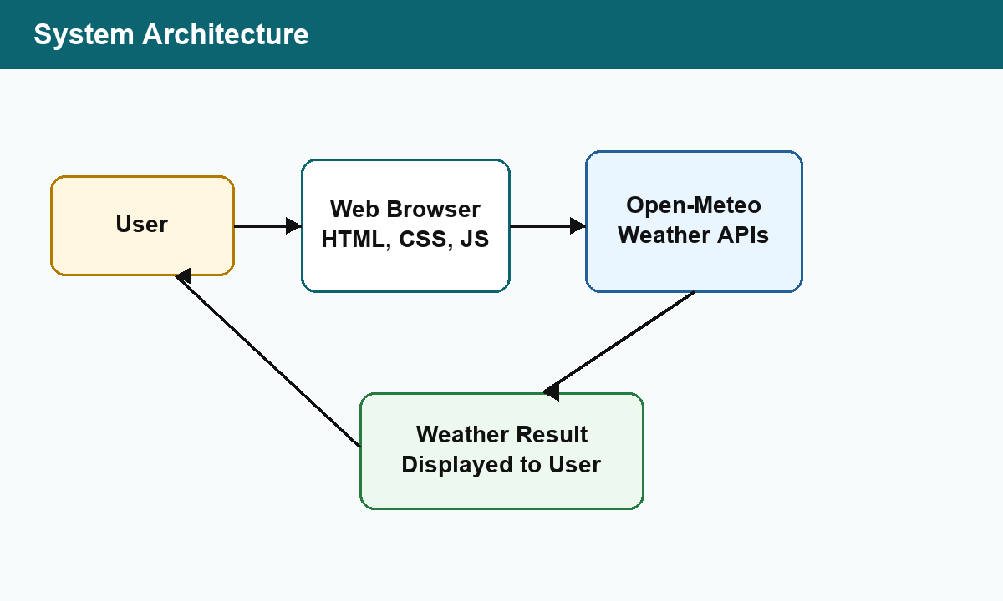
Figure 3.1 System Architecture
3.3.1 Data Flow Diagrams (Level 0, Level 1)
The Level 0 DFD shows the main flow of data from the user to the system and from the system to the weather API. The user submits a city name, the application processes it, the API returns JSON data, and the processed data is displayed to the user.
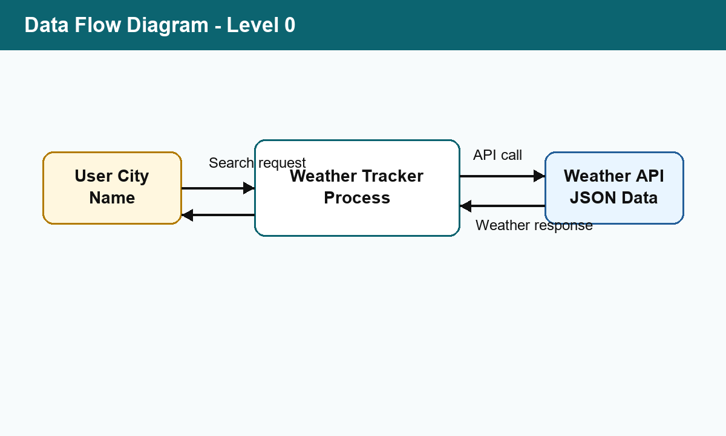
Figure 3.2 Data Flow Diagram - Level 0
3.3.2 Activity Diagram
The activity flow begins with user input. The system validates the input, performs API communication, checks the response, and displays either weather information or an error message. This activity supports repeated searches without page reload.
3.3.3 Flow Chart
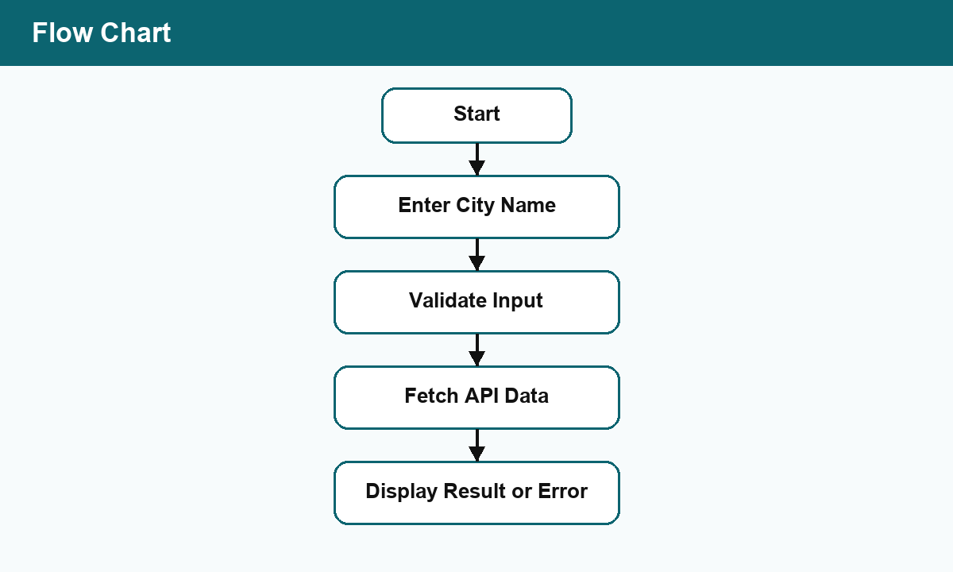
Figure 3.3 Flow Chart
3.3.4 Class Diagram
Although the implementation is function-oriented, the conceptual classes can be represented as User, Location, WeatherData, APIService, and DisplayComponent. These classes help explain how the system can be extended in the future if object-oriented design is required.
3.3.5 ER Diagram
The system does not use a persistent database in the current version, but the ER model is useful for future expansion. A user searches for a location, and each location is associated with weather data.
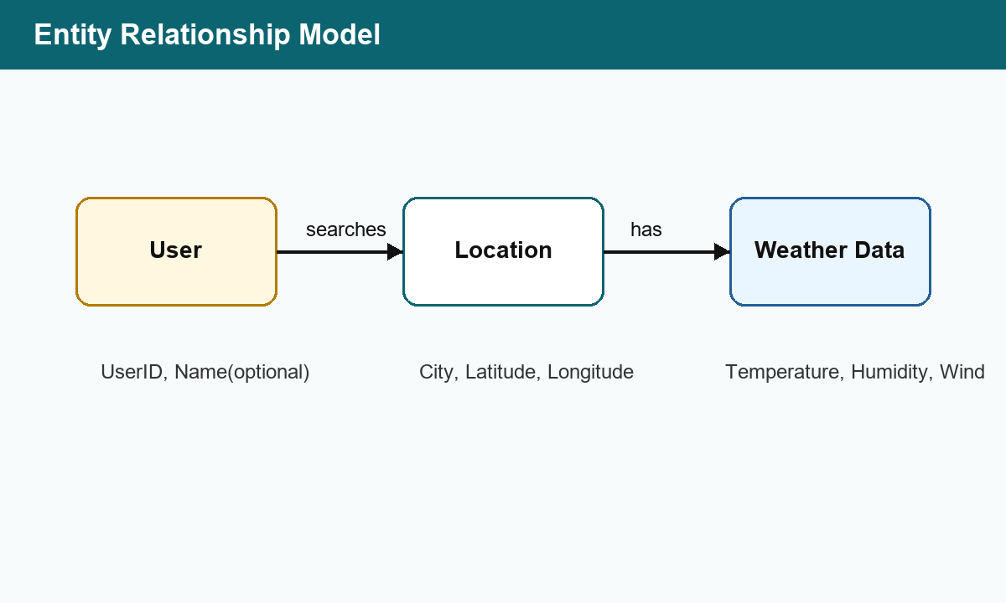
Figure 3.4 Entity Relationship Model
3.3.6 Sequence Diagram
The sequence diagram shows interaction among the user, user interface, JavaScript logic, and weather API during a successful search operation.
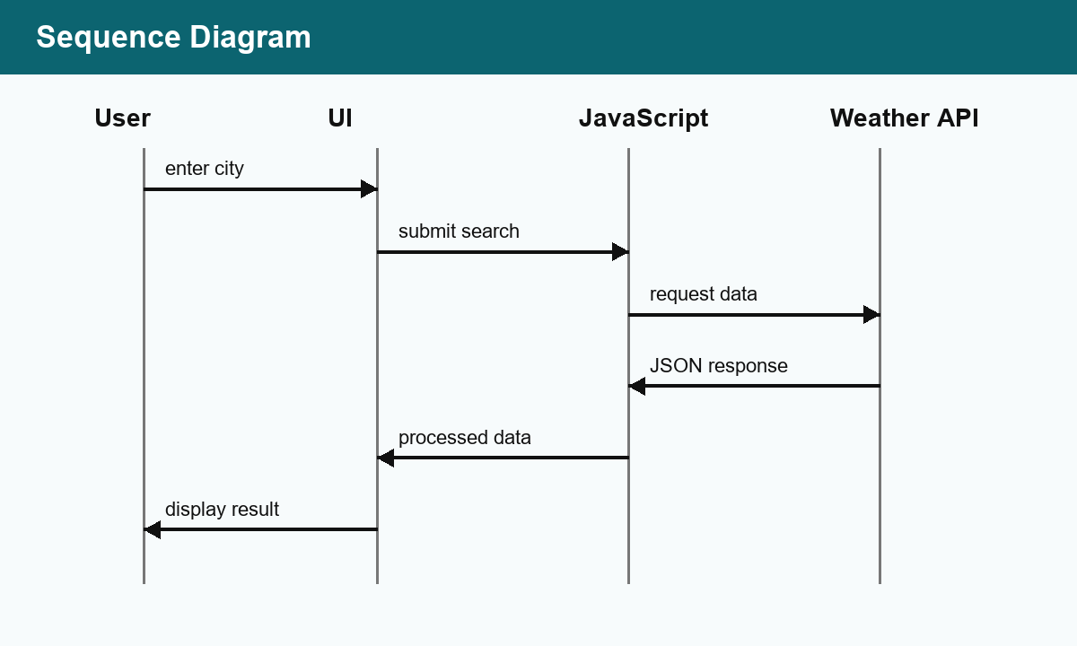
Figure 3.5 Sequence Diagram
3.4 Database Design
The current application does not use a traditional backend database. However, a conceptual database design is included for scalability. In a future version, users, locations, and weather data may be stored to support saved cities, history, and personalization.
3.4.1 Logical Database Design
Table 3.1 Data Dictionary
Data Name | Description
City Name | Name of the searched location
Latitude | Geographical latitude of the location
Longitude | Geographical longitude of the location
Temperature | Current temperature in Celsius
Humidity | Moisture level in percentage
Wind Speed | Current wind speed in kilometers per hour
Wind Direction | Compass direction of wind
Weather Condition | Textual description of current weather
3.4.2 Physical Database Design
No physical database is implemented in Version 1.0. The browser stores recent city searches using local storage, which is suitable for a lightweight client-side application. If a backend is added later, the data can be normalized into User, Location, and WeatherData tables.

Chapter-4
Implementation, Testing, and Maintenance
4.1 Introduction to Languages, IDEs, Tools and Technologies Used for Implementation
The Weather Tracker is implemented as a static web application using HTML, CSS, and JavaScript. HTML defines the structure of the search form, weather display panel, recent searches, and supporting content. CSS defines the visual layout, responsive behavior, colors, spacing, and card-based presentation. JavaScript performs input validation, API requests, JSON processing, DOM updates, error handling, and local storage operations.
- HTML: Used for page structure and semantic elements.
- CSS: Used for styling, responsive layout, and visual presentation.
- JavaScript: Used for logic, API communication, and dynamic UI updates.
- Open-Meteo API: Used for geocoding and current weather data.
- Browser Local Storage: Used to maintain recent searches.
- IDE/Text Editor: Used to write and manage project files.
4.2 Testing Techniques and Test Plans
Testing was performed to verify input validation, successful city search, invalid city handling, API failure handling, display accuracy, and responsive layout. The test cases are shown in Table 4.1.

Table 4.1 Test Plan
Test Case | Input / Action | Expected Result | Status
TC-01 | Open website | Home screen loads correctly | Pass
TC-02 | Search Indore | Weather data is displayed | Pass
TC-03 | Submit empty input | Validation message is shown | Pass
TC-04 | Search invalid city | City not found error is shown | Pass
TC-05 | Repeat search | New result replaces old result without reload | Pass
TC-06 | Open on mobile width | Layout adapts and remains readable | Pass
TC-07 | API/network failure | Failure message is shown without crash | Pass
4.3 Installation Instructions
- Copy the project folder to the local system.
- Ensure the folder contains index.html, styles.css, and app.js.
- Open index.html in a modern web browser.
- Make sure the device is connected to the internet for live weather data.
- Optionally deploy the folder on GitHub Pages or any static hosting platform.
4.4 End User Instructions
- Open the Weather Tracker website.
- Enter a city name in the search field.
- Click the Search button.
- View the temperature, humidity, wind speed, wind direction, and condition.
- Use recent searches to quickly search previously viewed cities.
- If an error is shown, check the spelling or internet connection and try again.

Chapter-5
Results and Discussions
5.1 User Interface Representation
The interface is designed to be simple and responsive. The first screen contains the project title, search input, search button, status message, weather card, and recent searches. The design avoids unnecessary information so the user can access weather data quickly.
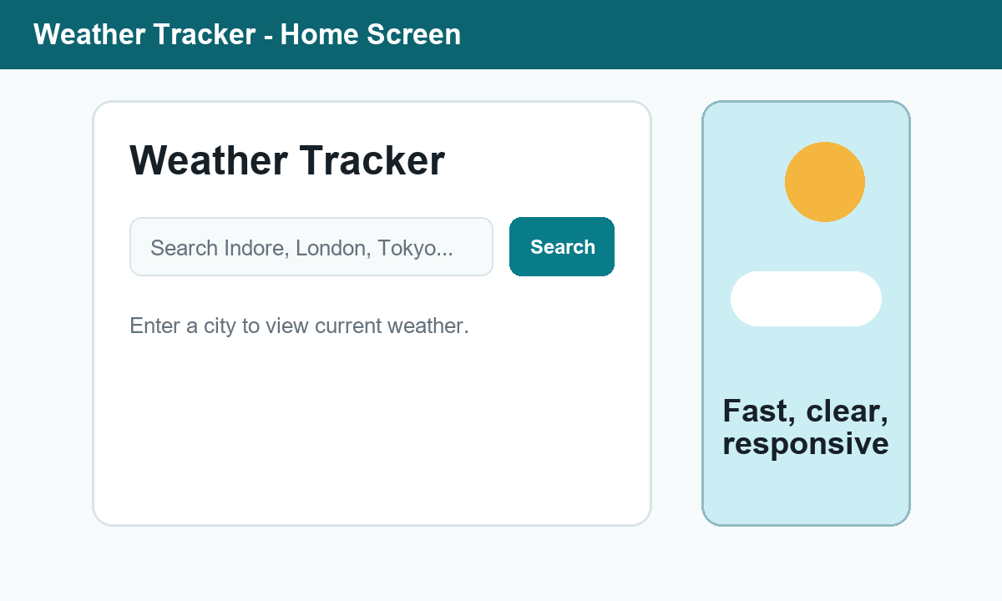
Figure 5.1 Home Screen

5.2 Brief Description of Various Modules of the System
Table 5.1 Module Summary
Module | Description
Input Component | Accepts city name from the user and validates input.
API Communication Component | Fetches geocoding and weather data through HTTPS requests.
Data Processing Component | Extracts required values from JSON response.
Display Component | Shows weather information, icons, and status messages.
Error Handling Component | Displays friendly messages for invalid input and API failure.
Recent Search Component | Stores and displays recent searched cities in browser local storage.
5.3 Snapshots of System with Brief Detail of Each
The weather display screen shows the searched location, condition, current temperature in Celsius, humidity, wind speed, wind direction, and update time.
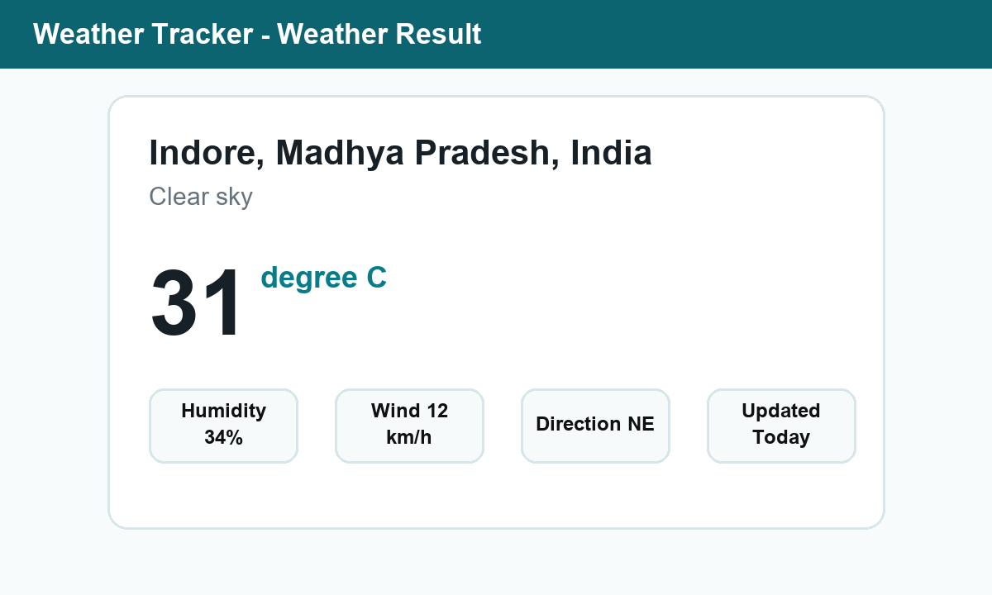
Figure 5.2 Weather Display Screen
The error screen demonstrates how the application handles an invalid city name. Instead of crashing, the system hides the weather card and displays a meaningful message.
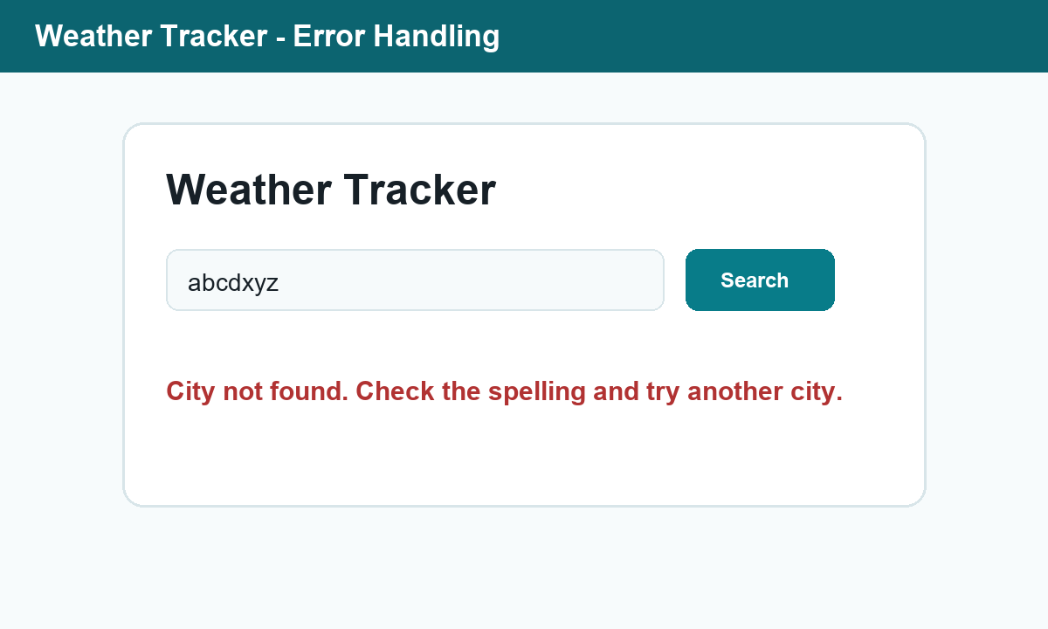
Figure 5.3 Error Message Screen
5.4 Back Ends Representation (Database to be Used)
The current version does not use a backend server or database. The external weather API acts as the data source. JavaScript in the browser sends requests to the API and processes the JSON response. This approach is suitable for a lightweight academic web application.
5.5 Snapshots of Database Tables with Brief Description
No physical database tables are implemented in the current version. For future expansion, a database may include tables for users, saved locations, and weather history. This would allow login, personalization, and saved reports.

Chapter-6
Summary and Conclusions
The Weather Tracker project successfully implements a responsive web application that provides real-time weather information for searched cities. The system accepts user input, validates the city name, retrieves location coordinates, fetches current weather data, processes JSON response, and displays results in a clear format.
The project satisfies the major requirements defined in the SRS and SDS, including city search, live data retrieval, temperature display, humidity display, wind information, weather condition display, error handling, repeated searches, and responsive design.
The project helped develop practical knowledge of frontend development, REST API integration, JSON handling, modular JavaScript, interface design, testing, and software documentation. It is lightweight and easy to deploy because it does not require a backend server in its current version.
The main limitation is dependency on internet connectivity and external API availability. The accuracy of displayed data also depends on the weather API provider. Despite these limitations, the application fulfills its academic and functional objectives.

Chapter-7
Future Scope
The project can be extended in several useful directions. Future versions may include 7-day weather forecast, automatic current location detection, weather alerts, saved favorite cities, user login, historical weather charts, multilingual support, and a mobile application version.
A backend server and database may also be added to store user preferences, search history, and notification settings. Additional APIs can be integrated to improve forecast accuracy and provide more advanced information such as air quality index, rainfall probability, UV index, and severe weather alerts.

Appendix
Appendix A: Key JavaScript Functions
The following important JavaScript functions are used in the project implementation:
- searchWeather(): Coordinates input validation, city lookup, weather fetching, and rendering.
- findLocation(): Sends city name to the geocoding API and returns latitude and longitude.
- fetchCurrentWeather(): Fetches current weather data using coordinates.
- renderWeather(): Displays processed weather data on the webpage.
- setMessage(): Shows success, loading, or error messages to the user.
- rememberCity(): Saves recent searches using browser local storage.
Appendix B: Project File Structure
File Name | Purpose
index.html | Defines the structure of the Weather Tracker web page.
styles.css | Defines visual design, spacing, colors, and responsive layout.
app.js | Contains validation, API integration, data processing, and UI update logic.

Appendix C: Detailed Requirement Traceability
Requirement traceability helps verify that each major requirement described in the SRS is connected with an implementation component and a test case. This improves review quality because every important feature can be checked against design, code, and testing evidence.
Table A.1 Requirement Traceability Matrix
Req. ID | Implementation Component | Verification Method | Status
REQ-01 | Search form in index.html | Manual input test | Completed
REQ-02 | Input validation in app.js | Empty input and invalid city tests | Completed
REQ-03 | fetch API calls in JavaScript | Valid city search test | Completed
REQ-04 | JSON response parsing logic | Weather data display test | Completed
REQ-05 | Temperature field rendering | UI verification | Completed
REQ-06 | Humidity field rendering | UI verification | Completed
REQ-07 | Wind speed and direction rendering | UI verification | Completed
REQ-08 | Weather code mapping | Condition display verification | Completed
REQ-09 | Error message component | Invalid input and API failure tests | Completed
REQ-10 | Dynamic DOM update | Repeated search test | Completed
REQ-11 | Responsive CSS rules | Desktop and mobile layout check | Completed
The traceability matrix shows that the project has covered the main expected behavior of a weather tracking application. It also gives evaluators a direct path from requirement to implementation and test result.

Appendix D: Detailed API Specification
The Weather Tracker depends on two API-level operations. The first operation converts a user-entered city name into geographic coordinates. The second operation uses those coordinates to request current weather values. Both operations are performed through HTTPS requests and the responses are processed as JSON.
Table A.2 API Operations
API Operation | Input | Output | Use in Project
Geocoding request | City name | Latitude, longitude, country, region | Finds the exact location for the searched city.
Forecast request | Latitude and longitude | Current temperature, humidity, wind speed, wind direction, weather code | Fetches live weather data for display.
Weather code mapping | Weather code from API | Readable weather condition | Converts numeric code into understandable text.
The chosen API approach avoids storing secret API keys in the frontend code. This is useful for an academic project because the application can be opened directly in a browser or deployed on static hosting without a backend server.

Appendix E: User Interface Design Details
The user interface is designed around a single common workflow: enter city, search, view result, and optionally search again. The visual layout uses a search section, weather result card, recent search list, and status message area.
Table A.3 User Interface Element Description
UI Element | Purpose | Expected Behavior
Title section | Identifies the application | Remains visible at the top of the page.
Search input | Accepts city name | Allows typed city names and clears unnecessary spaces.
Search button | Starts search operation | Triggers validation and API request.
Status message | Gives feedback | Shows loading, success, validation, or error message.
Weather card | Displays result | Shows current values only after successful search.
Recent searches | Improves repeated use | Stores and displays previously searched city names.
The design keeps the first screen useful without requiring navigation to another page. This is suitable for a minor project demonstration because the evaluator can understand the workflow immediately.

Appendix F: Input Validation and Error Handling
Validation and error handling are essential because API-based applications depend on user input and network availability. The Weather Tracker handles common failure cases through controlled messages rather than allowing the interface to break.
Table A.4 Validation and Error Handling Rules
Condition | System Response | User Benefit
Empty city field | Shows validation message and stops API request. | Prevents unnecessary network calls.
Unknown city name | Shows city-not-found message. | Guides the user to check spelling.
Network failure | Shows retry or connection error message. | Avoids confusion during temporary failure.
Slow response | Shows loading state until response arrives. | Confirms that the search is being processed.
Repeated search | Updates existing weather card. | Keeps the page clean and avoids duplicate results.
These controls make the application more reliable and professional. They also demonstrate that the project considers practical user behavior rather than only the ideal successful case.

Appendix G: Extended Test Cases
In addition to the main test plan, extended testing was considered to check edge cases, interface behavior, and data reliability. The following table can be used by an evaluator to repeat the testing process.
Table A.5 Extended Test Cases
Test ID | Scenario | Expected Result | Remarks
ET-01 | City name with leading/trailing spaces | Spaces are ignored and correct result is shown. | Input cleanup
ET-02 | City name typed in lowercase | Correct city result is shown. | Case-insensitive search
ET-03 | City name typed in uppercase | Correct city result is shown. | Case-insensitive search
ET-04 | Search button clicked multiple times | Latest request updates the interface. | Repeated action
ET-05 | Browser refreshed after searches | Recent searches remain available. | Local storage
ET-06 | Mobile screen width | Cards stack without overlap. | Responsive layout
ET-07 | Long city name | Text wraps or fits without layout break. | UI stability
ET-08 | API returns no result | Friendly error message appears. | Failure handling
The extended test cases confirm that the application remains usable under realistic conditions such as mixed input formats, repeated actions, small screens, and unavailable city data.

Appendix H: Maintenance and Version Control Plan
Maintenance planning explains how the project can be updated after submission. Since the application has three main files, changes can be managed in a simple and structured manner.
Table A.6 Maintenance Plan
Maintenance Area | Activity | Frequency
API compatibility | Check whether API endpoint format and response fields still work. | Monthly or before demo
Browser compatibility | Test in Chrome, Edge, Firefox, and mobile browser. | Before release
UI improvements | Adjust spacing, colors, and responsiveness based on feedback. | As required
Bug fixing | Correct validation, display, or API handling issues. | As required
Documentation | Update report, screenshots, and test results after changes. | Each version
A future team can use Git or another version control system to track changes. Meaningful commit messages should be used for every update, such as fixing validation, updating API handling, or improving mobile layout.

Appendix I: Deployment Plan
The Weather Tracker can be deployed on any static hosting service because it does not require a backend server. The deployment process is simple and suitable for demonstration.
Table A.7 Deployment Steps
Step | Deployment Activity | Expected Output
1 | Verify that index.html, styles.css, and app.js are in one folder. | Project folder is complete.
2 | Open index.html locally and test one valid city. | Local version works.
3 | Upload the folder to static hosting or repository pages. | Public link is generated.
4 | Open the hosted link in a browser. | Website loads from server.
5 | Test search and responsive layout. | Deployment is ready for presentation.
If the project is hosted online, the browser must be allowed to make HTTPS requests to the weather API. Static deployment is the most practical option for this version because the code is frontend-only.

Appendix J: Future Database Tables
Although the current version does not use a database, future versions may introduce login, saved cities, and historical weather records. The following editable tables describe a possible future database structure.
Table A.8 Proposed Future Database Tables
Table Name | Important Fields | Purpose
User | user_id, name, email, password_hash | Stores registered user information.
SavedLocation | location_id, user_id, city, latitude, longitude | Stores favorite or saved cities.
WeatherHistory | history_id, location_id, temperature, humidity, wind_speed, created_at | Stores weather records for later analysis.
AlertPreference | alert_id, user_id, condition_type, threshold_value | Stores notification preferences.
This future database design is optional but useful for scalability. It allows the Weather Tracker to grow from a simple weather search tool into a personalized weather monitoring system.

Appendix K: Detailed File-Level Description
The project uses a small number of files so that the structure remains understandable. Each file has a specific responsibility, and keeping these responsibilities separate helps maintain the application.
Table A.9 File-Level Description
File | Main Responsibilities | Editable Parts
index.html | Page layout, semantic structure, form, weather display containers, recent search area. | Labels, form placeholders, content sections.
styles.css | Colors, spacing, responsive layout, buttons, cards, typography, hover states. | Theme colors, breakpoints, shadows, sizes.
app.js | Validation, API calls, JSON processing, weather code mapping, DOM updates. | API fields, messages, display logic, storage behavior.
This separation follows common frontend practice. HTML should not contain complex logic, CSS should not contain application behavior, and JavaScript should not be overloaded with presentation styling.

Appendix L: Presentation Notes for Viva
The following points can be used while explaining the project to the subject teacher or viva panel. The points are written in a simple order that matches the application workflow.
- The project is a frontend-based Weather Tracker web application.
- The user enters a city name and clicks Search.
- JavaScript validates the input and sends a request to the geocoding API.
- The city is converted into latitude and longitude.
- The application sends the coordinates to the weather API.
- The API returns JSON data, which is processed by JavaScript.
- The weather card displays temperature, humidity, wind speed, direction, and condition.
- If the city is invalid or the network fails, the system shows a proper error message.
- The application is responsive and works on desktop and mobile screens.
- The project demonstrates HTML, CSS, JavaScript, REST API integration, testing, and documentation.

Appendix M: Security and Privacy Considerations
Even though the Weather Tracker is a small frontend project, security and privacy considerations are still important. The application does not collect personal information and does not require user login in the current version. It only processes the city name entered by the user and uses browser local storage for recent searches.
Table A.10 Security and Privacy Considerations
Consideration | Current Handling | Future Improvement
API key exposure | The selected API does not require a secret key in client-side code. | If another API is used, requests should be proxied through a backend.
Personal data | No personal data is collected. | If login is added, privacy policy and secure storage will be required.
Local storage | Only recent city names are stored locally. | Allow users to clear recent searches.
Network security | API requests use HTTPS endpoints. | Add monitoring for failed or suspicious requests in backend version.
The project is therefore safe for academic demonstration. The main privacy point is that searched city names may remain in the user's browser until cleared.

Appendix N: Feasibility Study
A feasibility study is used to confirm whether the project can be developed with available time, tools, skills, and resources. The Weather Tracker is feasible because it uses standard web technologies and a free weather API.
Table A.11 Feasibility Study
Feasibility Type | Observation | Conclusion
Technical feasibility | HTML, CSS, JavaScript, and API fetch calls are sufficient for the required features. | Feasible
Operational feasibility | The interface is simple and can be used without training. | Feasible
Economic feasibility | No paid software, paid server, or paid API is required for basic use. | Feasible
Schedule feasibility | The project scope is suitable for a mini project timeline. | Feasible
The feasibility study supports the choice of a lightweight frontend implementation. The project can be tested and demonstrated on any machine with a modern browser and internet connection.

Appendix O: Risk Analysis
Risk analysis identifies issues that may affect project execution, demonstration, or future maintenance. Since the application depends on an external API, network and API availability are the most important risks.
Table A.12 Risk Analysis
Risk | Impact | Mitigation
Internet not available | Live weather data cannot be fetched. | Test with internet before demonstration and show prepared screenshots if needed.
API service unavailable | Search result may fail temporarily. | Display a safe error message and retry later.
Invalid city spelling | No location result is found. | Show clear city-not-found message.
Browser incompatibility | Some features may not work in old browsers. | Use modern browsers such as Chrome, Edge, or Firefox.
Layout issue on small screens | Content may appear crowded. | Use responsive CSS and test mobile width.
The identified risks are manageable. Proper validation, fallback messages, and basic testing before presentation reduce the chance of project failure during evaluation.

Appendix P: Evaluation Checklist
The following checklist can be used before final submission or viva demonstration. It summarizes the important functional, formatting, and documentation checks for the Weather Tracker project.
Table A.13 Final Evaluation Checklist
Checklist Item | Expected Condition | Status
Website opens correctly | Home screen is visible without broken layout. | Done
Valid city search works | Weather card displays live data. | Done
Invalid input is handled | Error message appears without crash. | Done
Responsive layout works | Page remains readable on mobile width. | Done
Report tables are editable | Tables are native Word tables, not images. | Done
Report follows format | A4, Times New Roman, 12 pt, 1.5 spacing, required margins. | Done
Presentation is ready | Slides explain problem, objectives, design, testing, and conclusion. | Done
This checklist helps ensure that both the software and documentation are ready for academic submission.

Appendix Q: Detailed Learning Outcomes
The Weather Tracker project is not only a working software application but also a learning exercise in frontend engineering and documentation. The following table summarizes the academic learning outcomes achieved through the project.
Table A.14 Learning Outcomes
Learning Area | Outcome Achieved | Evidence in Project
Frontend structure | Understood semantic page structure using HTML. | index.html contains organized sections for search, result, and recent searches.
Visual design | Applied responsive CSS for different device widths. | styles.css contains layout rules and media behavior.
Programming logic | Used JavaScript functions to control application workflow. | app.js handles validation, API calls, and DOM updates.
API integration | Fetched and processed JSON data from live APIs. | Geocoding and weather API calls are implemented.
Testing | Prepared test cases for valid and invalid flows. | Main and extended test tables are included.
Documentation | Prepared SRS, SDS, report, and presentation material. | The report describes requirements, design, testing, and results.
These outcomes show that the project supports both practical implementation and academic documentation requirements. It also gives a foundation for larger software engineering work.

Appendix R: Submission Readiness Statement
The final submission package is prepared for academic review. The Weather Tracker website, project report, and presentation together explain the problem, solution approach, design, implementation, testing, results, conclusion, and future scope.
Table A.15 Submission Readiness
Submission Item | Purpose | Readiness
Website files | Demonstrate the working weather tracker. | Ready
Project report | Document the complete software development process. | Ready
Presentation | Support classroom or viva explanation. | Ready
Test cases | Show verification of functional requirements. | Ready
Editable tables | Allow teacher or student to modify tabular content. | Ready
The report has been formatted using A4 page size, Times New Roman text, 12-point body font, 1.5 line spacing, and the margins indicated in the supplied format reference. Tables are inserted as editable Word tables.

Appendix S: API Response Field Mapping
The application receives structured JSON from the weather API. Only the required fields are extracted and displayed so that the user interface remains simple and readable.
Table A.16 API Response Field Mapping
API Field | Displayed As | Processing Detail
temperature_2m | Temperature | Displayed in Celsius as the main value on the weather card.
relative_humidity_2m | Humidity | Displayed as percentage value for current air moisture.
wind_speed_10m | Wind Speed | Displayed in kilometers per hour.
wind_direction_10m | Wind Direction | Converted to a readable compass direction where required.
weather_code | Weather Condition | Mapped from numeric code to text such as clear sky or cloudy.
time | Updated Time | Used internally to identify the freshness of the current data.
Mapping only the required fields reduces interface clutter and makes the result easier to understand during demonstration.

Appendix T: Final Formatting Compliance
The supplied formatting images specify the main thesis/report formatting rules. The final report follows these rules as closely as possible in an editable Word document.
Table A.17 Formatting Compliance Checklist
Formatting Rule | Required Format | Applied in Report
Paper size | A4, 297 mm by 210 mm | Applied
Font | Times New Roman | Applied
Body size | 12 points | Applied
Line spacing | 1.5 line spacing | Applied
Top margin | 15 mm | Applied
Bottom margin | 22 mm | Applied
Left margin | 30 mm | Applied
Right margin | 20 mm | Applied
Tables | Should be readable and editable | Inserted as native Word tables
This page is included to make the formatting compliance clear for submission and review. The report tables are not screenshots; they can be selected and edited directly in Word.

Bibliography
- Open-Meteo API Documentation, https://open-meteo.com/
- OpenWeather API Documentation, https://openweathermap.org/api
- Mozilla Developer Network Web Docs, https://developer.mozilla.org/
- W3Schools Web Development Tutorials, https://www.w3schools.com/
- IEEE Software Engineering Standards and software documentation guidelines.

